# Algorithms

**Linear search**:

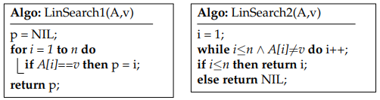

**Binary search**:

Sorted list entered:

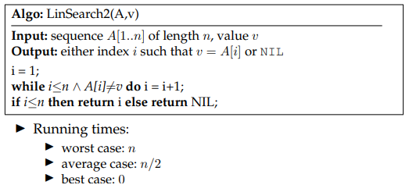

# Sorting

## Bubble sort

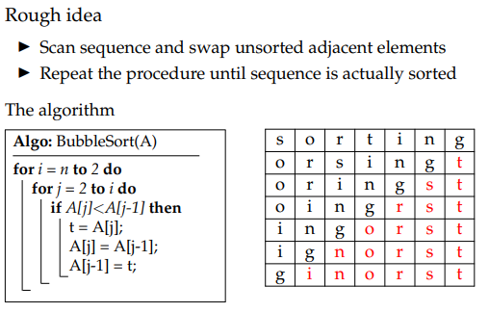

* Many comparisons
* Different amount of exchanges

## Selection sort

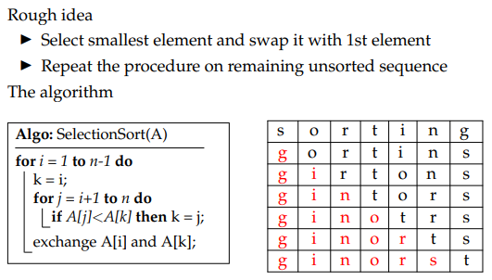

* Consistent number of comparisons and exchanges

## Insertion sort

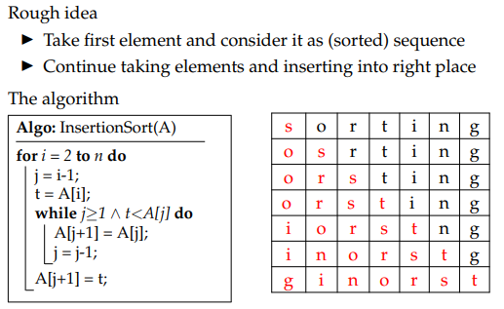

Inconsistent comparisons and exchanges

## Merge sort

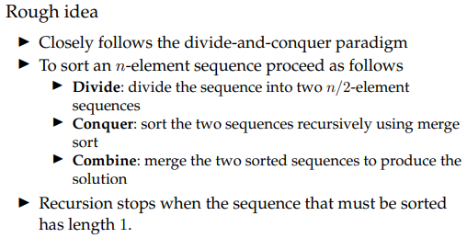

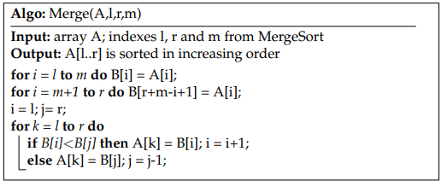

## Heap sort

# Algorithmic complexity

# Correctness

An algorithm is correct if it terminates and produces the desired output for any legal input.

# Asymptotic complexity

Goal: simplify the analysis of running time

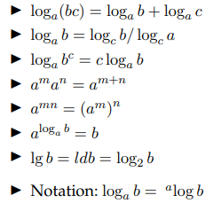

Big-O notation: worst case analysis

Big-Ω notation: best case analysis

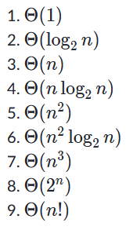

# Recurrences

Master method



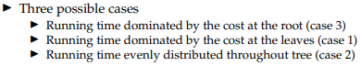

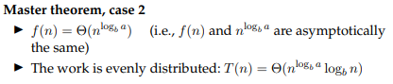

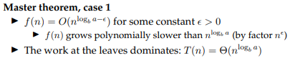

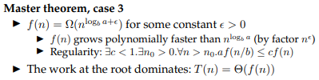

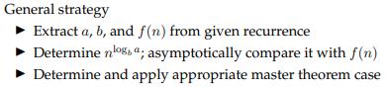

# Binary trees

Searching:

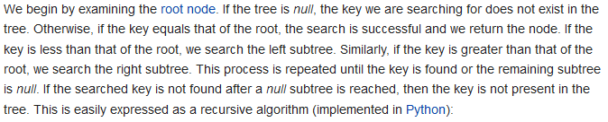

Insertion:

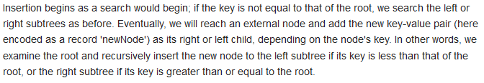

Deletion:

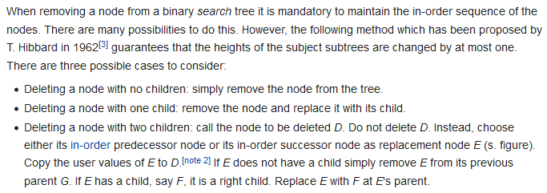

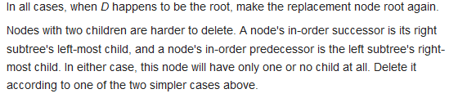

Predecessor: rightmost element in the left subtree

Successor: leftmost element in the right subtree

## Quicksort

Best case: n*log n

Worst case n^2

# Red-black tree

